Yea Show - 24th of November 2018

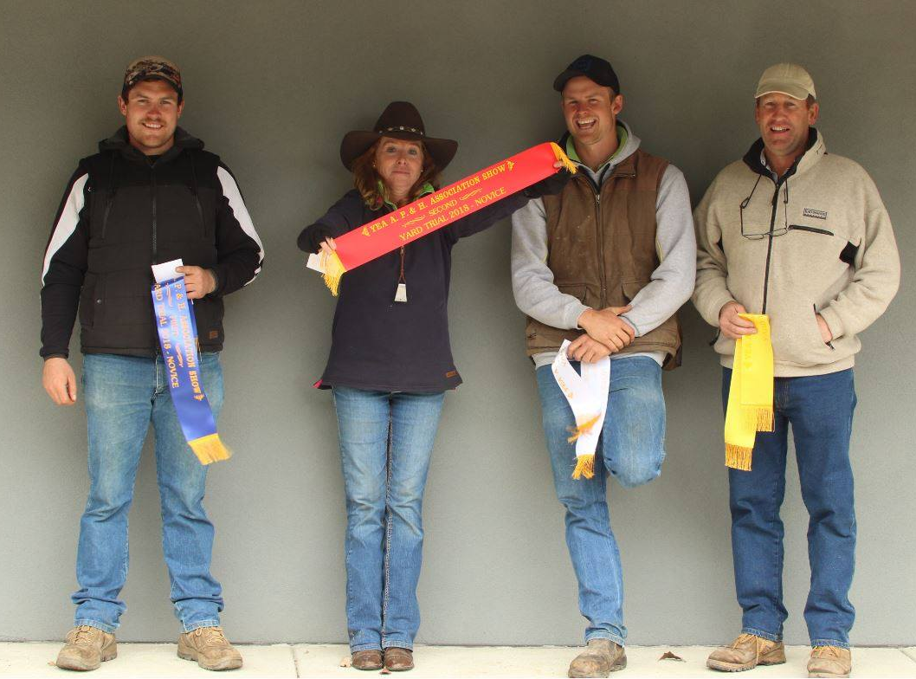

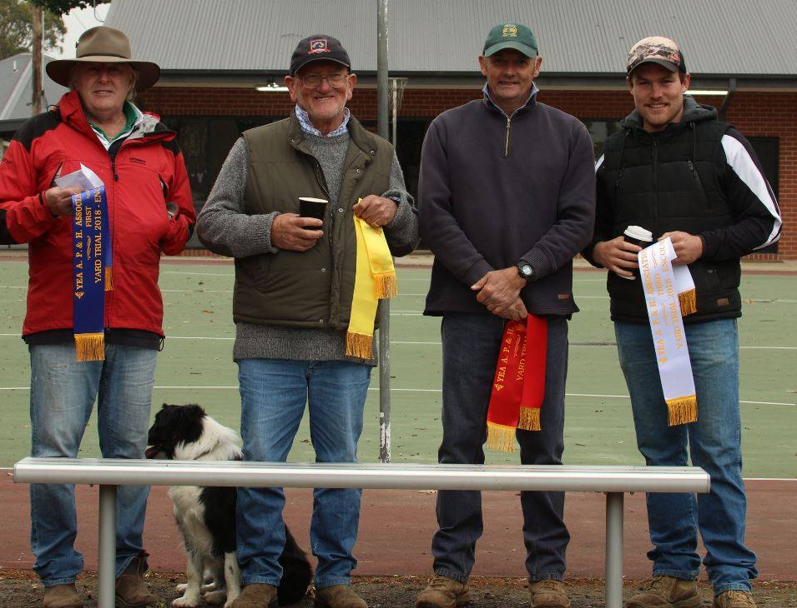

Open |  |  | Judge: | Darren McCainch
Place | Name | Dog | 1st Run | 2nd Run | Total
1st | Darryn Hannah | Scout | 87 | 77 | 164
2nd | Robyn Taylor | Trip | 80 | 83 | 163
3rd | Campbell Smedley | Tundabardi Chick | 77 | 86 | 163
4th | Darryn Hannah | Zinzan | 78 | 73 | 151
5th | Taleigha Emmerson | Gogetta Neville | 82 | 59 | 141
6th | Craig Ogier | Roustabout Gus | 86 | 51 | 137
Novice |  |  | Judge: | Rod Cavill
Place | Name | Dog | 1st Run | 2nd Run | Total
1st | Aoidh Doyle | Cash | 84 | 87 | 171
2nd | Robyn Taylor | Roundhill Maddie | 89 | 81 | 170
3rd | Campbell Smedley | Tundabardi Chick | 84 | 84 | 168
4th | Tim Fincham | Madge | 82 | 76 | 158
Encourage |  |  | Judge: | Darren McCainch
Place | Name | Dog | 1st Run | 2nd Run | Total
1st | Ross Furphy | Poppy | 60 |  | 60
2nd | Mark Wheeler | Stockmans Fly | 58 |  | 58
2nd | Aoidh Doyle | Cash | 47 |  | 47
4th | James Ryan | Neve | 46 |  | 46
